# Step 2 – Minimal Kubernetes

## Preliminary step

A preliminary step is to pass the domain names of the training boot and ui application in environment variables to nginx to allow for specific configurations of those links in Kubernetes.

In docker-compose.yaml add:

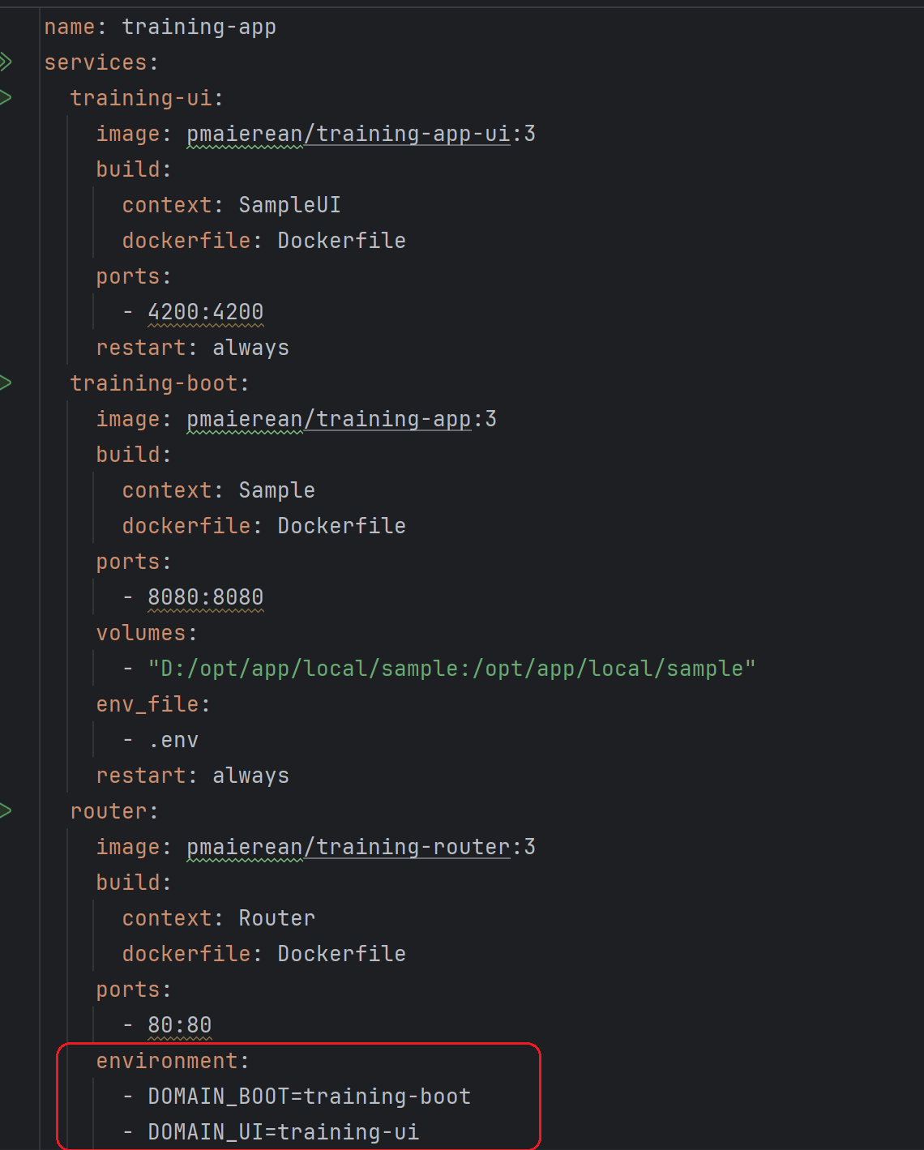

Modify the configuration file for nginx

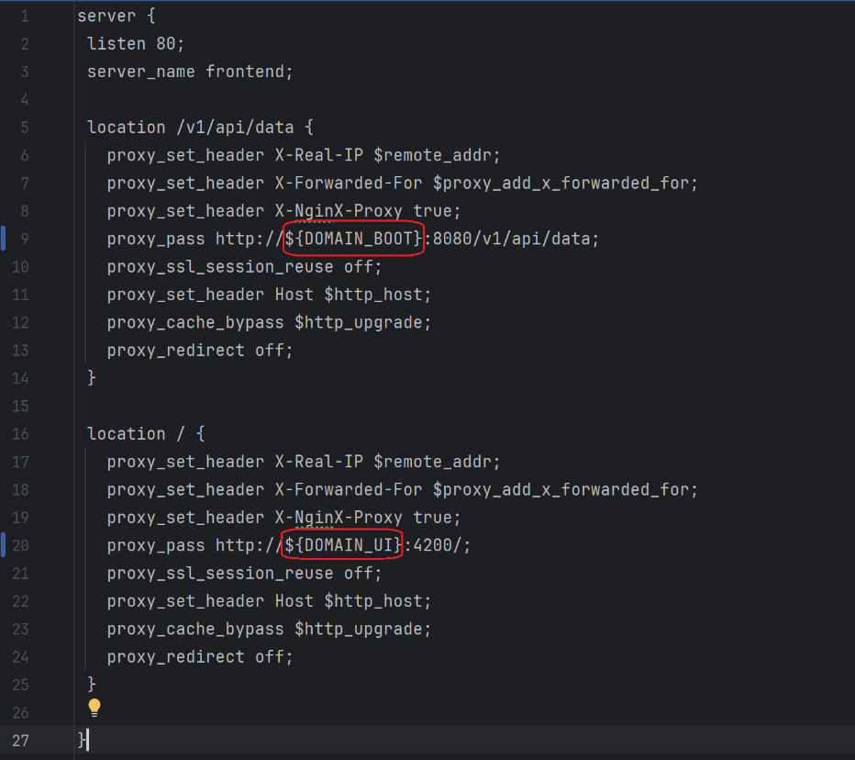

Modify Dockerfile for nginx

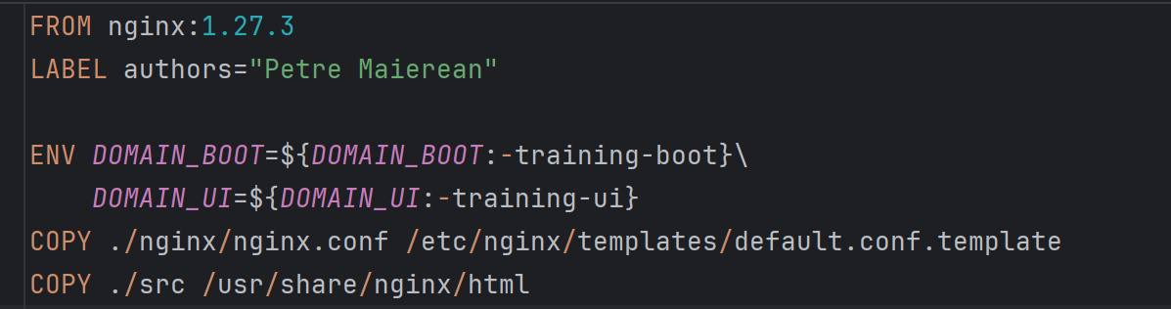

Note that placing the nginx.conf into the templates folder under the default.conf.template name instructs the application to compile that file and to move it into the expected location (‘/etc/nginx/conf.d/default.conf’) upon starting up.

## Using helm CLI to generate charts for those components

The [create](https://helm.sh/docs/helm/helm_create/) command can be used to generate Charts files. The structure of the helm project:

